**AFRO 398/REL 494**

**Religions of the Black Diaspora**

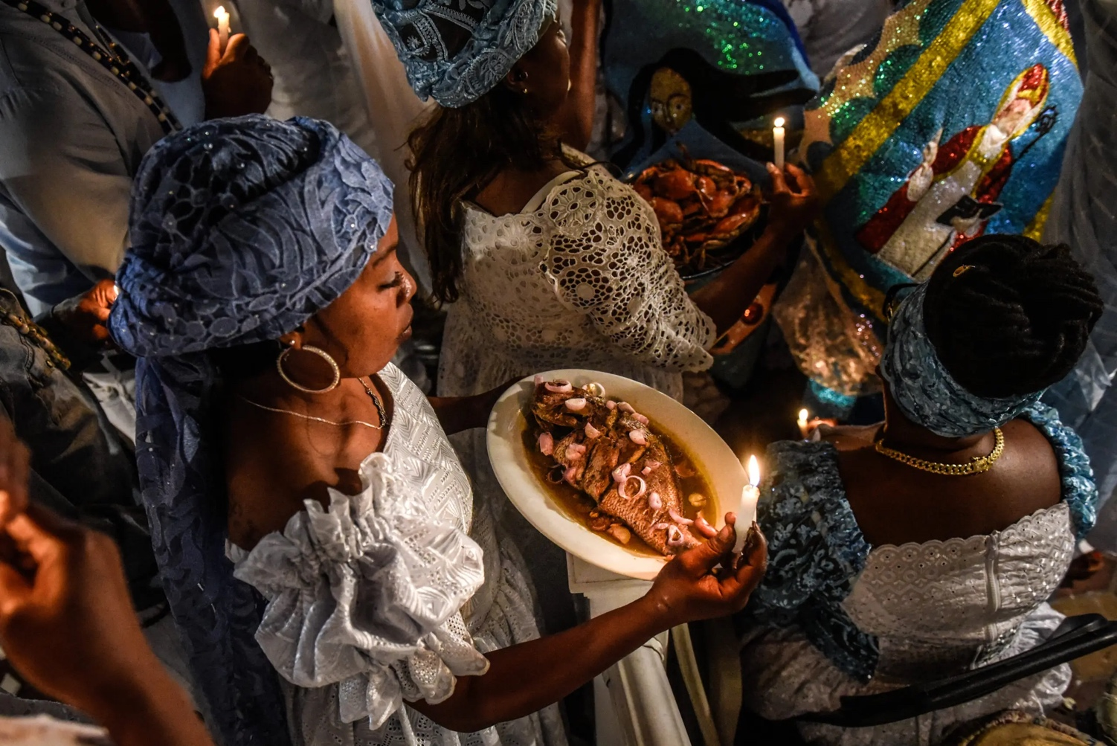

Professor: Dr. Leonard C. McKinnis, II

Wednesdays: 2 – 4:50 PM

Spring 2024

Instructor: Dr. Leonard C. McKinnis, II

Wednesdays: 2 – 4:50 PM

Meeting Location: Literature, Cultures, and Linguistics, 1112 (formerly FLB)

Office: African American Studies

1201 W. Nevada

[leonardm@illinois.edu](mailto:leonardm@illinois.edu)

Office Hours: By appointment via Calendly: <https://calendly.com/profmckinnis>

*\*\* The contents in this syllabus are open to amendment*

**Course Brief**:

This advanced seminar considers the diversity of Black religious thought and practice that emerge within the context of the absurd. It focuses our attention on the ways in which African Americans employ religion as the medium through which to dream of other worlds while resisting white supremacy and its religion. The course is built around three case studies: the Nation of Islam, Haitian Vodou, and the Black Coptic Church. Our quest in this endeavor is to engage questions of Black Studies such as the scandal of the human, the production of knowledge, and Afro-pessimism, through the lens of Diasporic Black religious imaginations.

**Critical Information:**

**Accommodation** of all students is the rule in this class. Everyone who attends in a spirit of learning is welcome. To ensure that disability-related concerns are properly addressed from the beginning, students with disabilities who require assistance should see me as soon as possible. To reiterate, I am committed to making my classroom and the content of this course as accessible to all as I possibly can. You can find the University of Illinois’s accommodations policy here:

<https://www.disability.illinois.edu/academic-support/accommodations>

**Academic integrity** concerns all of us and should guide your approach to your education. We qualify the word “integrity” with the word “academic” because of the particular requirements that exist with the university context (citations, writing your own papers, not cheating on quizzes and tests, etc.) not to imply that academic integrity is disconnected from personal integrity. How you choose to approach your work in an academic context is a direct reflection of your integrity as a person. The Student Code states that it is your responsibility to refrain from conduct that violates academic integrity, that may lead to suspicion of such infractions, or that aids others in such infractions. It is my responsibility as a professor and a member of this academic community to uphold the policy developed by the University of Illinois. You can find it here:

<http://studentcode.illinois.edu/article1_part4_1-401.html>

**Emergency response** recommendations can be found at the following website: http://police.illinois.edu/emergency- preparedness/. I encourage you to review this website and the campus building floor plans website within the first 10 days of class. http://police.illinois.edu/emergency-preparedness/building- emergency-action-plans/.

**Family Educational and Privacy Rights:** Any student who has suppressed their directory information pursuant to *Family Educational Rights and Privacy Act* (FERPA) should self-identify to the instructor to ensure protection of the privacy of their attendance in this course.  
See https://registrar.illinois.edu/academic-records/ferpa/ for more information on FERPA.

**Sexual Misconduct and Reporting:** The University of Illinois is committed to combating sexual misconduct. Faculty and staff members are required to report any instances of sexual misconduct to the University’s Title IX and Disability Office. In turn, an individual with the Title IX and Disability Office will provide information about rights and options, including accommodations, support services, the campus disciplinary process, and law enforcement options.

A list of the designated University employees who, as counselors, confidential advisors, and medical professionals, do not have this reporting responsibility and can maintain confidentiality, can be found here: <https://wecare.illinois.edu/resources/students/#confidential>

**Other information** about resources and reporting is available here: wecare.illinois.edu.

**Course Format**

This is an advanced undergraduate seminar in religion and Black studies. It is expected that participants understand and take seriously the demands of an advanced course. To this end, this seminar will take the format of a dialogue. That is, we will engage in critical conversation and discourse. Our primary means for this engagement will be that of Socratic method. I am therefore interested in how you engage the various readings at a second and third level reflection.

**Course Requirements**

1. Attendance and active seminar participation are mandatory by each participant. This includes thoughtful and insightful contributions to classroom discussion, as well as providing nuance of the same. To partly achieve this, participants are required to submit a weekly question / comment (a solid paragraph) in response to the reading via canvas. Your submissions should be posted by 11:00 am on the day of our class session. Participants may skip 3 posts. (25%)
2. One seminar leadership on a selected reading. Seminar participants will select a day of their choosing in which they are required to lead a discussion that corresponds with the reading for their selected day. Participants will have roughly 25-30 minutes to summarize and raise questions from the reading, and lead a discussion around the same. (25%)
3. One 750-800 words book or chapter review. The book review should come from a book in the course or a book you will use for your research paper. Instructor will provide examples. (25%)
4. Final Exam (25%). The final exam will take up a theme form the course. This essay exam will consist of two questions from which participants should select one to anwer. **The final exam will be available the last week of classes and will be due Wednesday, May 10th by 5:00 PM.**

**Bibliography (Books are in the University of Illinois Bookstore or Amazon)**

Required*:*

1. Stephen Finley, *In and Out of this World: Extraterrestrialism and Black Bodies in the Nation of Islam*
2. Leonard McKinnis, *The Black Coptic Church: Race and Imagination in a New Religion*
3. Eziaku Atuamam Nwakocha, *Vodou en Vogue: Fashioning Back Divinities in Haiti and the United States*

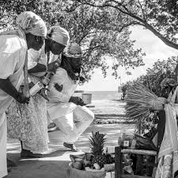

*Articles and book chapters available on Canvas:*

**Important dates**

Monday, January 18, 2022 - Spring Classes Begin  
Mon.-Sat., March 9-14, 2022 - Spring Break   
Monday, May 4, 2022 - Spring Classes End  
Weds.-Tues., May 6-12, 2022- Spring Final Exams

**Itinerary**

**Displacement and the Black Religious Imagination**

Week 1 (Jan 17) Class review, grounding the question of Black Religion

Week 2 (Jan 24) Mapping Africana Religions: Transnationalism, Globalization, and

Diaspora, 128-148(Available on Canvas)

Week 3 (Jan. 31) Judith Weisenfeld, *New World A-Coming,* Introduction, pp 1-22.

(Available in Canvas)

**Nation of Islam**

Week 4 (Feb. 7) C. Eric Lincoln Chapter 1, “The Verdict is Guilty – The Sentence

is Death,” in, *Black Muslims in America,* pp. 1-26

*(*Available on Canvas)

Stephen Finley, Introduction, *In & Out of this World: Extraterrestrialism and Black Bodies in the Nation of Islam,* “1-14

Week 5 (Feb. 14) Finley, Chapter 1, “Elijah Muhammad, The Myth of

Yakub, and the Critique of “whitenized” Black Bodies,” pp, 15-45.

Finley, Chapter 2, “Elijah Muhammad, Transcendent Blackness, and the Construction of Ideal Black Bodies”, pp, 46-73.

Week 6 (Feb. 21) Finley, Chapter 3, “Malcolm X and the Politics of Resistance:

*Visible Bodies, Language, and the Implied Critique of Elijah Muhammad,”* pp 74-99.

Week 7 (Feb 28) NO CLAS (Class Field Trip, Sunday, March 2nd)

The Historic Elijah Muhmmad Home

Followed by Lunch in Hyde Park

All expense covered.

**Vodou Identity and Aesthetics**

Week 8 (Mar. 6) Eziaku Atuama Nwokoha, Preface, *Vodou En Vogue:*

*Fashioning Black Divinities in Haiti and the United States* (pp xi-xiv)

Nwokoha, Introduction, (pp. 1-24)

Nwokoha, Chapter 1, “Addressing the Spirits,” (pp. 1-24)

Week 9 (Mar. 13) SPRING BREAK

Week 10 (Mar. 20) Nwokoha, Chapter 3, “How Tight Is Your Wrap: Tensions of Race

and Sexuality in Vodou Identity,” pp, 85-123

~~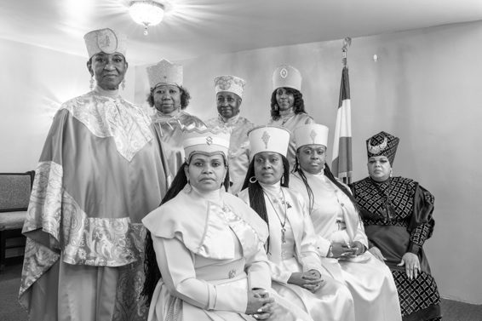~~

Week 11 (March 27) Nwokoha, Chapter 4, “Making Love to the

Spirit: Sex and Dreams in Spiritual Marriages, “ pp. 124-155.

**The Black Coptic Church**

Week 12 (April 11) Leonard McKinnis, Introduction:

Earthquake, in *The Black Coptic Church: Race and Imagination in a New Religion,* pp. 1-34

McKinnis, On Ethiopianism (From Chapter 1): pp. 47-60

Week 13 (April 18) McKinnis, Chapter 3, “Rituals of Freedom: Imagining and

Performing *Otherwise*,” pp. 92-124

Chapter 4, “Somehow, Someway:” Black Coptic Women and the

Politics of Gender,” pp. 125-151

Week 14 (April 25) McKinnis, Chapter 5, “Divine (Primordial) Blackness:

Imagination, Hope, and a Word on Afro-Pessimism,” pp. 152-185.

Week 15 (*Friday* May 3) Closing discussion